Parish of Sampford Peverell
Housing Needs Report

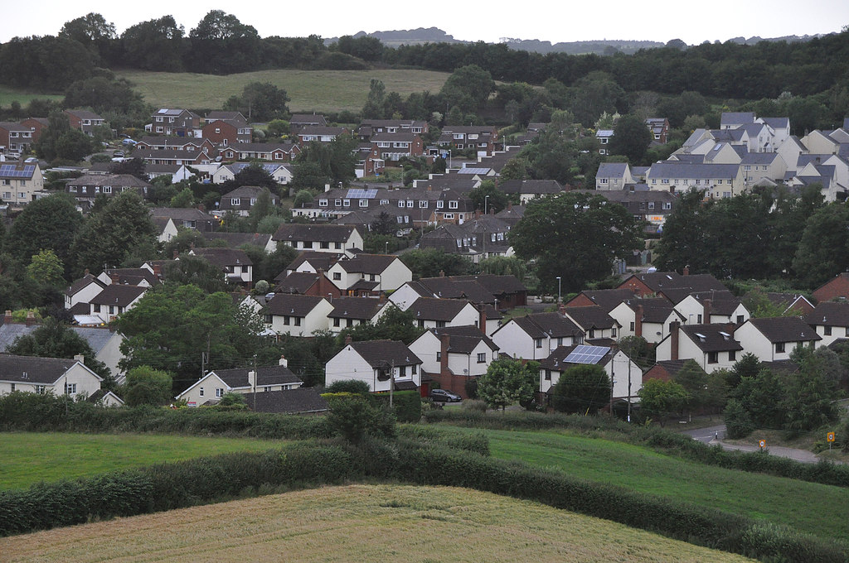

Produced by: Devon Communities Together

On behalf of: Sampford Peverell Parish Council

Date October 2019




Contents

- Executive Summary

- Aims of the Survey

- Survey History, Methodology and Response

- Introduction and Information about Sampford Peverell

- General Survey Findings

- Housing Aspirations of Older People

- Assessment of those wishing to move home within next 5 years

- Assessment of those in need of affordable housing

- Conclusions – Future Housing Need for Sampford Peverell

Please note that this document is the intellectual property of the Devon Rural Housing Partnership. If this document is used by any organisation to support a development then a fee will be charged. Details of this fee can be obtained from the Rural Housing Enabler at Devon Communities Together.

Devon Communities Together
First Floor, 3 & 4 Cranmere Court
Lustleigh Close
Matford Business Park,
Exeter. EX2 8PW
Tel 01392 248919

www.devoncommunities.org.uk

1 Executive Summary

Principal Conclusions

- The survey identified a need for 6 affordable homes within the next 5 years.

Key findings

Affordability

- The survey found 5 households in housing need who could not afford to buy or rent in the open market.
- 1 additional reply was received from a household on Devon Home Choice

Tenure

- 4 of the households in need qualified for affordable rent, 2 may be able to afford a shared ownership property.

Size of Property Required

- 3 x 1 or 2 bedroom properties for singles / couples
- 2 x 2 bedroom properties for families
- 1 x 4 bedroom property for a family

Other Findings

- 559 surveys were delivered and 178 survey forms were returned. The response rate was 32%.

  - 77% of those who answered the question said they would be in favour of a small development of affordable housing for local people. 29 households did not answer this question.

2. Aims of the Survey

- To investigate the housing need, tenure and size of homes required for local people living or working in the parish and those wishing to return.
- To establish the general level of support for new homes in the parish with an emphasis on homes for local people with housing needs.
- To establish the views of the whole community on future housing in the parish.
- To assist the Parish Council and District Council with future planning for the parish.

3. Survey history, methodology and response

3.1 History
Sampford Peverell Parish Council and Community Land Trust decided to carry out a housing need survey for the parish to identify housing need. Survey forms were finalised and 559 forms were hand delivered to every household in the parish. Parishioners were able to return the survey in a reply paid envelope. The deadline for the return of the survey was 7th October 2019.

3.2 Methodology
The survey was carried out using a standard methodology approved by local planners. Background notes on the methodology can be obtained from the Rural Housing Enabler.

The survey form was in 3 parts. The first section asked a limited number of questions about the type of household and their support for affordable housing. All residents were invited to respond to this part of the survey. The second section was aimed at parishioners aged over 55 to gauge the specific needs of older residents. The third part of the survey was designed to be completed by households who intend to move home within the next 5 years and wish to remain living in the parish. Both those who have an affordable housing need and those who wish to buy on the open market were invited to complete this section of the form. A reminder was also sent to those on the Devon Home Choice register who did not complete a survey form.

3.3 Response

- 178 surveys were returned, which is a response rate of 32% of all dwellings surveyed.

- 19 out of the 178 responses were returned with Part 3 completed.

It should be noted that whilst apparent inconsistencies in responses are followed up, the information given is taken at face value.

4. Introduction and Information about Sampford Peverell

4.1 Overview of Sampford Peverell
Sampford Peverell is a small parish located between Wellington in Somerset and Tiverton in Devon and falls within the Mid-Devon local authority area. It is minutes from J27 of the M5
and has a mainline railway station, Tiverton Parkway, on the outskirts of the village. There are also hourly bus services to Exeter and Tiverton, all of which give extremely good transport connections to other local towns and beyond. The Grand Western Canal also runs through the village and is a popular tourist attraction.
Village amenities include a village hall, two places of worship – the Parish Church and Methodist Chapel, a primary and pre-school, GP surgery, two pubs, a convenience store, allotments and a farm shop. There are also several play and sports facilities including 2 children’s play areas, angling ponds, football and cricket pitches, tennis courts, a cycle path along the canal and a 9 hole golf course. There are also numerous other amenities and facilities a few minutes away in Tiverton.

The community boasts several organisations including a local history society, garden club, art club, bell ringers, choir, Twinning Association, Royal British Legion and a senior citizens club. There are also several sports and leisure groups including walking and cycling. There is a Caring Friends society who help with transport for medical or dental visits.

There are no large employers within the parish and the majority of people travel to the larger surrounding towns to work.

4.2 Population Figures
In the 2011 census the usually resident population of Sampford Peverell was 1302 in 559 households.

4.3 Type of Accommodation
In the 2011 Census the types of accommodation in the parish were broken down as in Table 1 below.

Table 1
Detached  house/bungalow | Semi-detached house/bungalow | Terraced  house/bungalow | Flat | Caravan / mobile home | Total
252 | 199 | 70 | 14 | 2 | 537

4.4 Bedroom numbers
In the 2011 Census the number of bedrooms per dwelling was broken down as in Table 2 below. The majority of homes have 3 or 4 bedrooms with very few smaller 1 bedroom properties.

Table 2
1 bedroom | 2 bedrooms | 3 bedrooms | 4 bedrooms | 5 or more | Total
16 | 84 | 248 | 160 | 29 | 537

When viewed together these tables show that there is a lack of smaller, cheaper accommodation in the parish with detached properties of 3 bedrooms plus being the most prolific. There are very few 1 bedroom properties or flats in the parish which may be suitable for those on low incomes.

4.5 Property Prices and Rent
In the last 2 years the Land Registry has recorded 31 property sales in the parish. The average price of properties whose value was shown was £329,565. Prices ranged from £149,000 for a leasehold 2 bedroom flat to £625,000 for a detached 4 bedroom house.

There are currently 10 property listings on the Rightmove website. The cheapest house on the market at the moment is a 3 bedroom property for £219,950. There are only 3 houses for sale under £250,000.
To assess whether a household can afford to buy in the open market it is necessary to look at the cost of an entry level property in the local market. This is done by comparing information on recent house sales and homes currently on the open market. Average lower quartile rents are identified by comparing local private rents gained from the housing need survey with rents of properties currently on the market. From this information, we can establish typical rents to assess affordability. There were no one bedroom properties for sale or rent on the open market at the time of writing this report therefore prices have been estimated from previous surveys. The figures used to assess affordability are set out in Table 3 below.

Table 3
Size | Property price | Weekly rent
1 bedroom | £150,000 | £130
2 bedroom | £180,000 | £150
3 bedroom | £220,000 | £190

There are currently 36 council/housing association owned properties in Sampford Peverell. These are all 2 and 3 bedroom properties.

4 affordable homes have been let in the last 2 years. Therefore lettings of current affordable housing stock will have little impact on future need figures.

5. General Survey Findings

5.1 In favour of a small local development
Respondents were asked if they would be in favour of a small number of homes for local people being built if the need for affordable housing were proven. 77% of those answering the question said they would be in favour. 23% said they were against any development. It should be noted that 29 households did not respond to this question. Fig.1 below shows the breakdown.

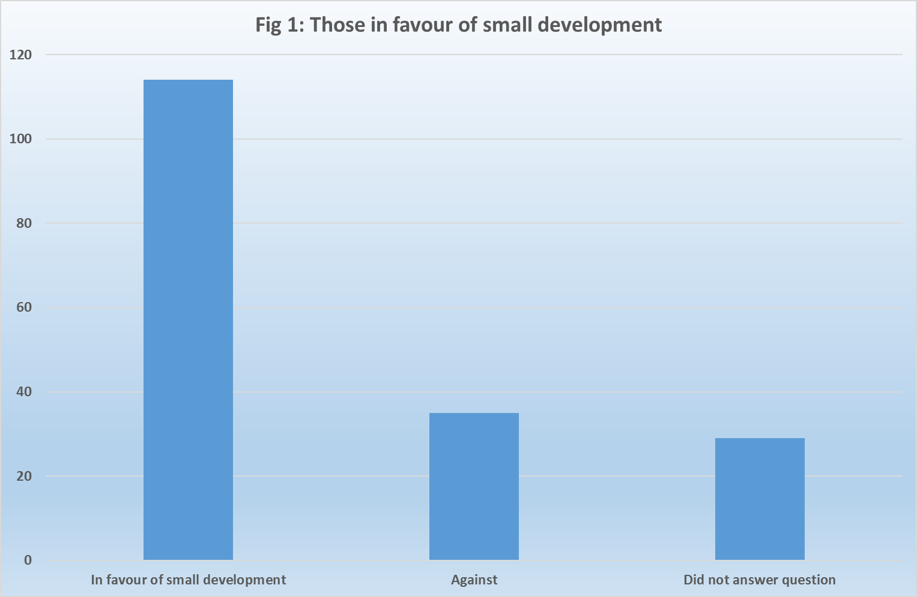
5.2 Site suggestions and general comments
57 individuals commented on possible sites within the parish and made more general comments about housing in the parish. These suggestions and comments will be made available to the Parish Council on a separate document.

5.3 Knowledge of those who have left parish in last 5 years
Respondents were asked if they knew of anybody who had had to leave the parish in the last 5 years due to lack of suitable housing.

- 2 households replied that they did know of someone

5.4 Current tenure
Of the 175 respondents who provided details, 154 (88%) own their own home and 13 (7%) rent from a private landlord. The remaining 8 households (5%) are made up of 2 living in a shared ownership property, 3 living with relatives and 3 renting from a housing association or local authority. Figure 2 below shows the breakdown of tenure.

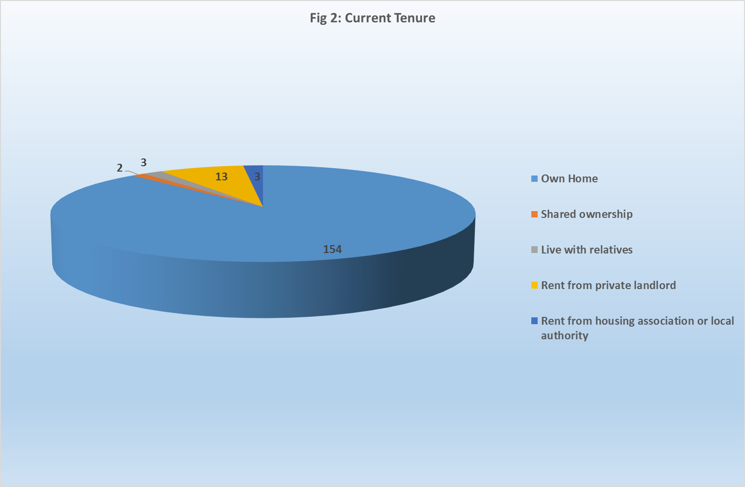

5.5 Main or second home
None of the respondents was a second home owner.

5.6 Parish of Residence
Respondents were asked which parish they lived in. All but 1 live in Sampford Peverell parish. The other household lives in Holcombe Regis.

5.7 Number of bedrooms in current home
Respondents were asked how many bedrooms their current home has. The replies are shown in Table 4 below. 5 did not answer this question.

Table 4
Number of bedrooms | 1 | 2 | 3 | 4+
 | 7 | 22 | 62 | 82

5.8 Future plans
Respondents were asked whether they intended to move home within the next 5 years. If they answered Yes to this question they were asked to complete Part 3 of the form.

- 22 households stated they did intend to move within the next 5 years

5.9 Community Land Trusts (CLTs)
Respondents were asked whether they would consider becoming a member of the local CLT.

- 7 households showed an interest and left contact details.
- 14 further households stated they were already members of the Sampford Peverell CLT.

- Housing needs and aspirations of older residents

Part 2 of the questionnaire was directed at residents over the age of 55. The number of people over the age of 55 is set to rise significantly across the UK over the next 20 years. In 2014 the Office for National Statistics published population projections for the next 20 years. These figures show that by 2034 the percentage of people over the age of 55 will have increased by 23% across Devon and by 24% in Mid Devon during that period.

206 people answered Part 2 of the survey from 127 households with at least one member over the age of 55. This is 71% of the total number of households who responded to the survey.

6.1 Age of Respondents to Part 2 survey
Respondents were asked to give their age in 10 year bands. As can be seen in Table 5 below, the majority of those who replied (74%) were aged between 55 and 75.

Table 5
Age Group | 55-65 | 66-75 | 76–85 | Over 85
Number | 70 | 82 | 40 | 14

6.2 Future Housing Plans
Households were asked about their future housing plans.

- 18 households plan to move within the next five years. Of these, 9 would like to remain in Sampford Peverell.
- 1 of these households is eligible for affordable housing.
- 26 further households expect to move after five years.
- 83 have no plans to move at the moment.

6.3 Adaptability of current home
Respondents were asked if their current home was adaptable to meet changing needs.

- 93 households felt that their home was adaptable
- 26 felt that their home was not adaptable

6.4 Type of Accommodation preferred by older persons
Older households were asked what type of accommodation they may need in the future. The majority preferred a home better suited to their needs but not designed for older people. Preferences are shown in Table 6 below.

Table 6
Type of Accommodation Preferred by Older Persons | Number
Home better suited to needs but not specifically designed for older people | 29
Home specially designed for older people | 7
Residential / nursing home | 5

6.5 Considerations when choosing next home
Households were asked to list the most important considerations when choosing a new home.
They could give more than one reason. The reasons are listed below in Table 7.

Table 7
Most important consideration | Number
Need to downsize to a smaller more manageable home | 20
Proximity to shops/amenities | 18
Cheaper running costs | 16
Need to be near family / carers | 15
Proximity to public transport | 13
Need one level for medical reasons | 11

The two most important considerations were that older persons wished to move to a smaller, more manageable property with that was close to shops and amenities.

6.6 Conclusion – Older Persons Needs
The older persons’ survey shows that the majority of households (65%) have no plans to move home. However, the parish does have a number of older households who wish to downsize to smaller accommodation that is easier to maintain, has lower running costs and is close to amenities and support.

Only 1 of the 9 households that expect to move home within the next 5 years and remain in Sampford Peverell are eligible for affordable housing. The remaining 8 households would require open market housing. Small open market bungalows, flats and houses can be built, however, developers who build open market homes do not usually attach any kind of local connection covenant as this reduces the value of the homes. This means that any open market properties cannot be guaranteed for local people.

Meeting the housing needs of this group of people should be given further consideration.

- Assessment of those wishing to move to a new home in
Sampford Peverell within the next 5 years

Part 3 of the survey was aimed at those who expect to need to move home within the next 5 years and remain in Sampford Peverell. It asked questions regarding size and make-up of the new household, local connection and financial circumstances. This information helps to identify the number of households that are eligible for both open market and affordable housing in the parish and the size, tenure and type of homes required.

22 households indicated a need to move within the parish in the next 5 years, however only 19 completed Part 3 of the survey. These 19 households have been included in this part of the assessment.

7.1 Minimum bedroom requirement
Respondents were asked the minimum number of bedrooms they would require in their new home. Table 8 below shows the breakdown. It should be noted that there are criteria relating to affordable housing that set the number of bedrooms that a household are eligible for based on the number of adults and children in that household. 3 household did not specify.

Table 8
1 bedroom | 2 bedroom | 3 bedroom | 4 bedroom
1 | 5 | 7 | 3

7.2 Timescales for moving
Households completing this part of the form were asked to identify when they would need to move.

- 10 households indicated a need to move within the next 1-3 years
- 8 households indicated a need to move within the next 5 years
- 1 household did not specify a timescale

7.3 Housing tenure
Respondents were asked what type of accommodation they would consider moving to. The results are shown in table 8 below. Respondents could choose more than one option.

Table 8
Shared ownership/ equity | Affordable/Social rent | Self-build | Discounted market | Rent to buy | Open market
8 | 4 | 6 | 6 | 6 | 9

7.4 Reasons for moving
Respondents were asked why they wished to move home. They could tick more than one box.

Table 10 overleaf shows why households need to move.

Table 10
Reason for wishing to move | No of respondents
Need to move to a home with more bedrooms | 6
Need to downsize to a home with fewer bedrooms | 4
Need to move for health/mobility reasons | 4
Struggling to afford current home | 3
Private tenancy ending | 3
Wish to move back to the parish and have a strong local connection | 2
Sharing kitchen and bathroom facilities with someone who is not going to be rehoused with you | 1
Other (want to buy property, want detached home, children) | 4

7.5 Budget for new home
Respondents who wished to purchase a home were asked about their budget. Table 11 below shows the breakdown of replies.

Table 11
£150,000 - £200,000 | £200,000 - £250,000 | £250,000 - £300,000 | £300,000 - £350,000 | £350,000+
6 | 5 | 3 | 1 | 2

8. Assessment of those in affordable housing need
This section of the survey looks at the number of households who would qualify for an affordable home in the parish, based on their household income and savings.

8.1 Exclusions
All 19 of the households who completed Part 3 of the survey have been assessed and 12 have been excluded

- 8 own their own home and have no need for affordable housing.
- 4 have sufficient funds to buy an open market home and wish to do so

This leaves 7 who may qualify for affordable housing.

8.2 Local Connection
In order to qualify for affordable housing, respondents must have a local connection to Sampford Peverell. Local connection criteria are set out by Mid Devon District Council and are detailed below:-

- The intended household has been continuously resident in the Parish for at least five years.
- The intended household is permanently employed in the parish and their work is primarily based in the parish. For the purposes of this criterion, ‘permanently employed’ means having held a permanent employment contract for a minimum of 16 hours per week for at least the preceding 6 months.
- The intended household were previously resident in the parish for a period of at least three years within the last 10 years.
- The intended household has a close living relation resident in the parish. This means immediate family members (parents, siblings, dependent and non-dependent children) who themselves live in the Parish and have done so for at least the preceding five years.

2 of the respondents do not have this connection and have been excluded from the final figures. This leaves 5 households in housing need.

8.3 Preferred housing tenure
The survey also asked households who had a housing need which tenure of housing they were interested in. Respondents could give more than one option. The responses are listed in Table 12 below.

Table 12
Type of housing | Interested
Shared ownership/equity | 2
Affordable Rent | 3
Self build | 1
Discounted market sale | 2
Rent to buy | 3

8.4 Housing Options
The housing options available to the 5 households in need are now given consideration.

Respondents provided information on income and savings which allows an assessment of what the household can afford to pay for their accommodation. These incomes are shown in Figure 3 below.

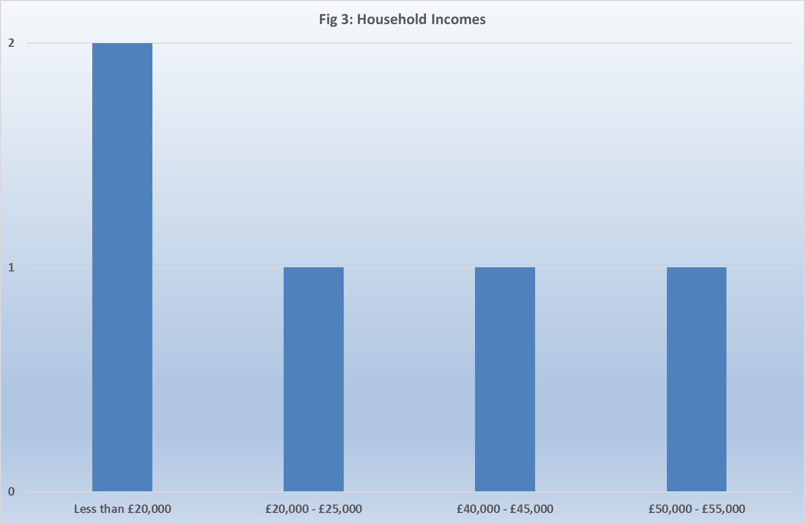

Given the financial circumstances of the households in need, 2 may be able to afford a low cost ownership home and expressed an interest in this type of purchase. The other 3 would require affordable rented housing.

8.5 Other evidence of housing need
As well as this survey other evidence of housing need should be considered. The housing waiting list or register for Devon is called Devon Home Choice. Applicants are given a banding from A to E depending on their level of need*. There are 7 households resident in the parish registered on Devon Home Choice. Details are set out below.

Table 13
Devon Home Choice band | 1 bed | 2 bed | 3 bed | Total
Band A (Emergency need) | 0 | 0 | 0 | 0
Band B (High) | 0 | 1 | 0 | 1
Band C (Medium) | 0 | 0 | 0 | 0
Band D (Low) | 0 | 0 | 0 | 0
Band E (No Housing Need) | 3 | 3 | 0 | 6
Total | 3 | 4 | 0 | 7

Only 2 of the households who are registered on Devon Home Choice completed the survey. Due to this apparent disparity, the other 5 households who are registered with Devon Home Choice and living in the parish were contacted separately by letter and 1 further positive reply was received which gives a final total of 6 households in need.

8.6 Housing Mix
The suggested mix of housing is shown in Table 14 below. This takes account of the family makeup as declared on the survey form and the type of housing required.

Table 14
Type of Property | Affordable Rent | Low cost home ownership | Totals
1 or 2 bedroom property for single people | 2 | 0 | 2
1 or 2 bedroom property for couples | 0 | 1 | 1
2 bedroom property for families | 2 | 0 | 2
4 bedroom property for families | 0 | 1 | 1
Totals | 4 | 2 | 6

1 household requires a property with level access. This is the 4 bed home.

9. Conclusion - Future Housing Need for Sampford Peverell

Overall, it must be remembered that this Housing Needs Survey represents a snapshot in time. Personal circumstances are constantly evolving. Any provision of affordable housing, would, by necessity, need to take account of this. However, given the level of response to the survey, and in spite of the potential for circumstances to change, the Parish Council can feel confident in the results of this survey. The survey has identified a need in the near future for 6 units of affordable housing.

Any further action taken towards meeting this housing need will require the support of the Parish Council and wider community consultation. Should the Parish Council wish to address the identified housing need, the Rural Housing Enablers are available to help identify potential sites, conduct site appraisals and facilitate the process of identifying potential development partners as well as any other ongoing assistance that may be required.

As the needs of households are constantly evolving the level and mix of need in this report should be taken as a guide. In particular it may be appropriate to vary the mix of sizes provided. This report remains appropriate evidence of need for up to five years. However if there is a significant development of affordable housing in the parish which is subject to a local connection requirement and substantially meets the need identified in the report it will normally be necessary to re-survey the parish before any further development to address local needs is considered.

Recommendation

It is recommended that the Parish Council:

- Note this report
- Consider the options for addressing the need for 6 affordable homes.

*The five DHC priority bands are:
Band A – Emergency Housing Need
Your application will only be placed in this band if your need for housing is assessed as so exceptional that you must take priority over all other applicants. For example:
• you have an urgent health or wellbeing need
• your home is in a state of emergency disrepair
• you need to move to escape violence or the threat of violence, harassment or a traumatic event
Substantial evidence must exist to award this priority.

Band B – High Housing Need
Your application will be placed in this band if:
• a Devon council has accepted that you are statutorily homeless and it is not considered possible and appropriate for you to find private rented accommodation
• a Devon council assesses that it will not be possible and appropriate for you to find private rented accommodation, you are subject to the Prevention or Relief duty of the Homelessness Reduction Act, and you are taking the actions set out in your Personalised plan
• you are severely overcrowded
• you are a tenant of a Devon Home Choice partner landlord and want to move to a smaller home
• you have a high health or wellbeing need
• your home is in a state of high disrepair
• you are ready to move on from supported housing

Band C – Medium Housing Need
Your application will be placed in this band if:
• you are overcrowded and lack 1 bedroom
• you have been assessed as having a medium health or wellbeing need
• you live on, or above the 4th floor with children under 8
• you have served in the armed forces and are assessed to be in urgent housing need
• you need to need to move for work, where you would otherwise have to travel more than 30 miles (each way) from home to work
Band D – Low Housing Need
Your application will be placed in this band if:
• a Devon council has accepted that you are statutorily homeless but it is considered possible and appropriate for you to find private rented accommodation
• you have no permanent home. For example you have been assessed as non priority or
intentionally homeless by a Devon local authority, or are‘sofa surfing’
• you have been assessed as having a low health or wellbeing need
• you share facilities, such as a toilet, bath, shower or kitchen (for example you are living with your parents)
• you meet a local priority agreed by the local authority managing you application
• you have a housing need but have no local connection to Devon
• you have been assessed as having deliberately worsened your circumstances

Band E – No Housing Need
From your application it has been assessed that you are adequately housed.
This usually relates to a financial need. A household is judged as being adequately housed if they are living in accommodation that is the right size for their family and in good condition and they have no health or mobility issues.

This data only gives details for 537 dwellings, this is because data for empty homes is not included.
Data correct as of 3/9/19

